GSK
RWD Person-Level Products Consumption Domain – Ops Guide

Document Version : 1.0

Version History

Version | Date | Revised By | Changes Made - Reasons for the Change
V1.0 | 24-Nov-2025 | Shivam Pandey | Initial Release
Table of Contents
1. Introduction 5
1.1. Document Purpose 5
1.2. Terms and Definitions 5
2. Resource Checklist 6
2.1. User Requirements 6
2.2. Environment Requirements 6
3. How to 7
3.1. Login into ADLS 7
3.2. Login into Databricks 7
3.3. Login into GitHub 7
3.4. Login into ADF 8
3.5. Log into Azure DevOps 8
4. Framework Readiness 9
4.1. Source Data Availability 9
4.1.1. Data Feed Refresh for preconfigured datasets 9
5. Azure Data Factory 10
5.1. Triggering Pipeline 10
5.2. Triggering Pipeline from Middle Node 10
5.3. Cancelling a Step in Pipeline Run 11
5.4. Rerun a Pipeline from Failed Step 11
5.5. Running pipeline for a specific refresh 12
5.6. Linked services with ADF 13
6. Troubleshoot 14
7. Email Notification 15
8. Code Repository & Folder Structure 17
8.1. main 17
8.2. global_config 17
8.3. python/code/ 18
8.4. python/utilities/ 19
8.5. Steps to update code in Databricks & GitHub 20
9. Quality Management 22
9.1. Target DQ 22
10. Data Product Publish 23
11. Changes to Dataset and Pipeline 24
11.1. Source Table Name Change 24
11.2. Source Column Name Change 24
11.3. Source schema Name Change 24
11.4. Updating/Adding Target DQM check 25
11.5. Redeploying Updated Code in the Pipeline 25
12. Mitigation plan 27

Introduction

Document Purpose
The purpose of this document is to provide detailed guidelines and work instructions for the operations team on how to create the data product using flatiron raw data. This document is intended for any user to understand how the framework operates and how to configure it for any data refresh. As such, this guide can be used as training material or a user manual.
It contains documentation for the Data Product creation pipeline— detailing each step involved.

Terms and Definitions
The table below identifies the terms and acronyms used specifically in this document.

Term/Acronym | Definition
ADF | Azure Data Factory
ADLS | Azure Data Lake Services
DQ | Data Quality
EHR | Electronic Health Records
RWD | Real World Data
DEV | Development
PROD | Production
UAT | User Acceptance Testing

Resource Checklist
Prior to running the ADF Pipeline, the user needs to check that the below programs are installed and set up on their computer, and all the prerequisites are met.

User Requirements
Approved users must have valid GSK credentials with the below listed access privileges.

    - Access to ADLS
    - Access to ADF to trigger pipelines.
    - Access to GitHub for Code repository
    - Access to Databricks for code development & deployment

Environment Requirements
Check if the following infrastructure items are running and are accessible to the user, to execute the steps as part of these operations.
- Raw/source data should be available at the required locations:
  - MarketScan Commercial abfss://rwem@codvmtus6abfstestdev001.dfs.core.windows.net/data/unified/use_rwem-csi/commercial_claims/
  - MarketScan Medicare: abfss://rwem@codvmtus6abfstestdev001.dfs.core.windows.net/data/unified/use_rwem-csi/medicare/
  - Optum SES: abfss://rwop@codvmtus6abfstestdev001.dfs.core.windows.net/data/unified/use_rwop-csi/optum_ses/
  - Optum DOD: abfss://rwop@codvmtus6abfstestdev001.dfs.core.windows.net/data/unified/use_rwop-csi/optum_dodr/
  - Reference data: abfss://rwre@codvmtus6abfstestdev001.dfs.core.windows.net/data/unified/use_rwre-csi/athena/
- Backend Infrastructure for ADF should be up and running.
- Databricks cluster should be up and running.
- The catalog should include the schema where the tables will be written.

How to

Login into ADLS
- Paste the below container link in browser and press enter.
- This will open the ADLS container with all required data storage.

Environment | Storage Account Name | Container Name | Link
DEV | codvmtus6abfstestdev001 | rwpl | rwpl - Microsoft Azure
UAT | codvmtus6abfsuat001 | rwpl | rwpl - Microsoft Azure
PROD | codvmtus6abfsprod001 | rwpl | rwpl - Microsoft Azure

Login into Databricks
- Paste the below link in the browser and press enter.
- Click On “Sign in” to log in through GSK SSO.

Environment | Cluster Name | Link
DEV | co-dvmt-rwpl-us6-etl-uc-cluster-dev01 | Cluster Details - Databricks
UAT | co-dvmt-rwpl-us6-etl-uc-cluster-uat01 | Cluster Details - Databricks
PROD | co-dvmt-rwpl-us6-etl-uc-cluster-prod01

Login into GitHub
- Paste the below link in the browser and press enter.
- https://github.com/gsk-tech/rwpl-cd.git
- Click on Continue to log in through GSK SSO.
- Select the Required branch to refer to the Code Framework.
- More Details on the Code Repository and Folder Structure are mentioned in section 6.
- Below is the name of branch in different environments:

Environment | Data Products Branch | Deployment Branch Name
DEV | DEV | Dev
UAT | UAT | UAT
PROD | Main | Main

Login into ADF
- Paste the link below in the browser and press enter.
- Click on “Log into GitHub” >” Authorize” to log in to ADF through GitHub
- Select the required branch and click on “save.”

Environment | Name | Link
DEV | codvmtrwplus6adfdevtst01 | ADF
UAT | codvmtrwplus6adfuat01 | ADF
PROD | codvmtrwplus6adfprod01 | ADF

Note: To access the pipeline in ADF, users must have “write” access to the GitHub repository. (Links can be found in section 3.3)

Log into Azure DevOps
- Click on following link to access Azure DevOps https://dev.azure.com/Devops-RD/
- Sign-in using GSK SSO.
- Click on ‘RD_Tech_Development_Data_Fabric’ Project title.
- Pipeline Deployment steps are mentioned in detail in section 11.6.

Framework Readiness

Source Data Availability
User needs to make sure that certain parts of the framework are configured according to the use cases presented below before running any conversion.

Data Feed Refresh for preconfigured datasets
a. User should make sure that the dataset for which the load is to be triggered should have source data available on ADLS as per the guidelines mentioned below (in point b)
b. Ensure that tables for dataset are available at a location which follows the format below.

Data Set | Schema Name
MarketScan Commercial | rwd_marketscan_commercial_<refresh>
MarketScan Medicare | rwd_marketscan_medicare_<refresh>
Optum SES | rwd_optum_ses_<refresh>
Optum DOD | rwd_optum_dodr_<refresh>
Reference Athena | rwd_reference_athena_<athena_refresh>

Note: In order to refresh the data product, we will require the progression data (enh_advnsclcprogr) . Currently, the progression data is supposed to be delivered in the m01 and m07 data versions and hence, the triggers in ADF have been setup for those refreshes only.
In case of non-delivery of progression data, it will result in automatic failure in the ETL pipeline scheduled refreshes.

Azure Data Factory
Users must make sure they have access to the ADF Pipelines. These are the pipelines which user needs access to:
- cdm_master
- cdm_transformation_commercial
- cdm_transformation_medicare
- cdm_transformation_ses
- cdm_transformation_dod
- cdm_qc
The purpose of the pipeline is to convert raw data into a data product.

Triggering Pipeline
To trigger the pipeline, user can follow following steps:

- Log into the ADF portal.
- Launch the ADF studio.
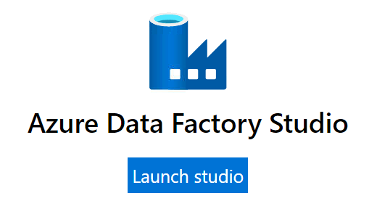
- Select the Author from the left navigation bar.
- Select required pipeline name from the Pipelines dropdown in the left tab.

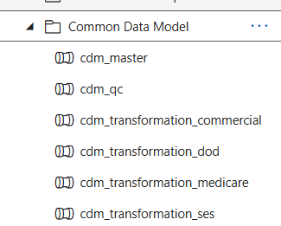

- Click on Trigger Now option of Add Trigger dropdown in the tool bar.
- Click on OK to confirm the trigger.

Triggering Pipeline from Middle Node
To trigger the pipeline, user can follow following steps:

- Log into ADF portal.
- Launch the ADF studio.

- Select Author from the left navigation bar.

- Select required pipeline name from the Pipelines dropdown in the left tab.


- Right click on Nodes not to be triggered during run. Click on deactivate.
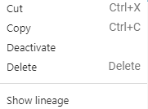

- Click on Save.
- Click on Trigger Now option of Add Trigger dropdown in the tool bar.
- Click on OK to confirm the trigger.

Cancelling a Step in Pipeline Run
To cancel the pipeline run, user can follow following steps:

- Log into ADF portal.
- Launch the ADF studio.

- Select Monitor from the left navigation bar.
- Select Pipeline runs from the Runs section of the Dashboard tab.
- Select required pipeline run from the list of runs.
- Click on Cancel Options dropdown from the toolbar.
- Select Cancel to cancel only one step.
- Select Cancel Recursively to stop entire Pipeline.

Rerun a Pipeline from Failed Step
To rerun the pipeline from failed step, user can follow following steps:

- Log into ADF portal.
- Launch the ADF studio.

- Select Monitor from the left navigation bar.
- Select Pipeline runs from the Runs section of the Dashboard tab.
- Select required pipeline run from the list of runs.
- Click on Rerun from failed activity dropdown from the toolbar.

Running pipeline for a specific refresh
refresh is a pipeline parameter which is used to identify the schema name which will be utilized as source data for the creation of the data product. Refresh value is of the format <Last 2 digits of Year>q<Month number>

By default, the pipeline is supposed to be run in February (refresh value: < Last 2 digits of year>q1) and August (refresh value: < Last 2 digits of year>q7) month. In case the pipeline is run anytime between February and August, then <current year>q1 will be used automatically by the pipeline, and for August to February, current year>q7 will be used automatically by the pipeline.

In case the user receives a request to run the pipeline for refreshes other than the two described above, user can follow following steps:

- Log into ADF portal.
- Launch the ADF studio.

- Select Author from the left navigation bar.
- Select required pipeline name from the Pipelines dropdown in the left tab.



- Within the pipeline, go to the parameters section
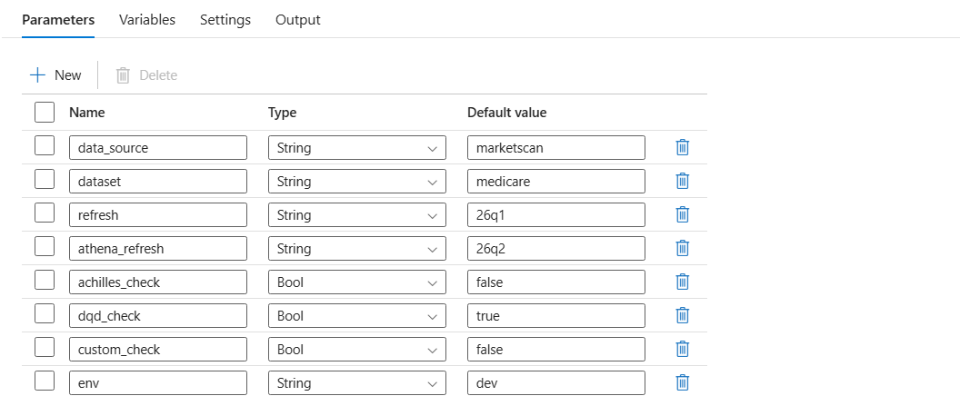
- Withing the parameter section, navigate to the parameter named: ‘refresh’

- Within the parameter, enter the refresh value of the schema for which we want to run the pipeline. E.g. If we want to run the pipeline for the schema rwd_marketscan_commercial_26q1, then 26q1 should be entered within the refresh parameter.
- Click on Trigger Now option of Add Trigger dropdown in the tool bar.
- Click on OK to confirm the trigger.

Linked services with ADF
The following linked services in ADF are shared with the Eagles team:
- Databricks: Used for code execution and deployment.
- Key Vault: Securely stores and manages sensitive information (secrets, keys, and certificates), ensuring controlled access and secure application interactions.
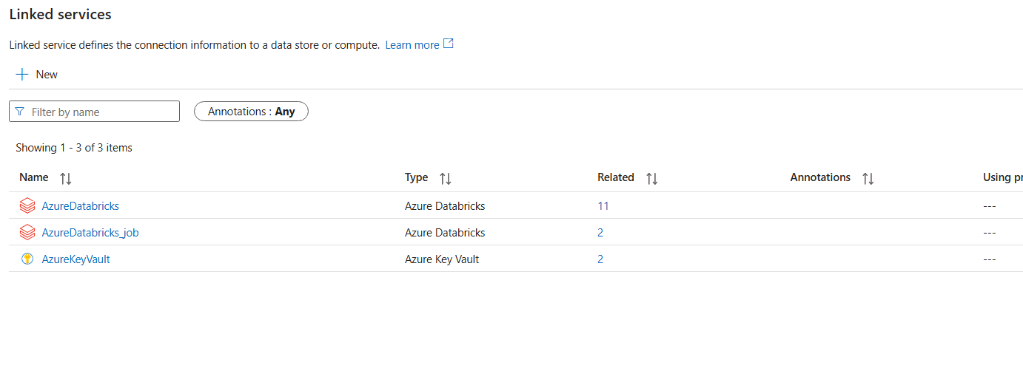

Troubleshoot
To trouble shoot a failed step, user can follow below steps:

- Through Databricks Notebook
- Log into ADF portal.
- Launch the ADF studio.

- Select Monitor from the left navigation bar.
- Select Pipeline runs from the Runs section of the Dashboard tab.
- Click on comments icon in the Status column of run from list of Pipeline runs.
- A popup will open with error details & link to notebook run.

- Through Log Files
- Log into Databricks.
- Open DBFS file browser from the file tab.
- Go to file location to access log file: /dbfs/mnt/rwpl/raw/logs/{pipeline_name}_{step_name}_{step_start_date_timestamp}.log

Email Notification
User will be notified with status of the run after success or failure of the pipeline. The email notification will have following information:
- Run Status
- Run Environment
- Refresh
- Run Start Date & Time

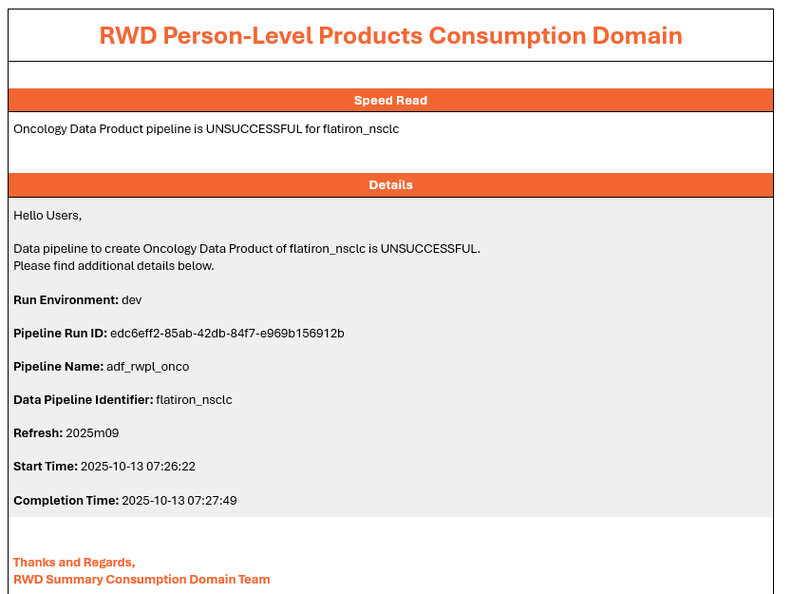

Code Repository & Folder Structure
Entire code framework for the pipeline is available in GitHub “rwpl-cd” repository as per below folder structure in “main” branch.

main
- In “rwpl-cd” GitHub repository, there is a branch “main”.
Inside Common-data-model folder below folders are present:
  - configuration: It has all configurations that are specific to Marketscan (commercial & medicare) & Optum dataset (ses & dod).
  - “Configuration” has two folders named:
    - env: It has all configurations specific to the environment (dev , uat & prod)
    - global: It has all configurations specific to the datasets.
  - script: Serves as the central directory for all Python-related components (code + utility) of the pipeline.
  - “script” has two folders named:
    - code: It has all the python scripts used in the pipeline.
    - utility: It has the utility files i.e. the .py files used in the process scripts.

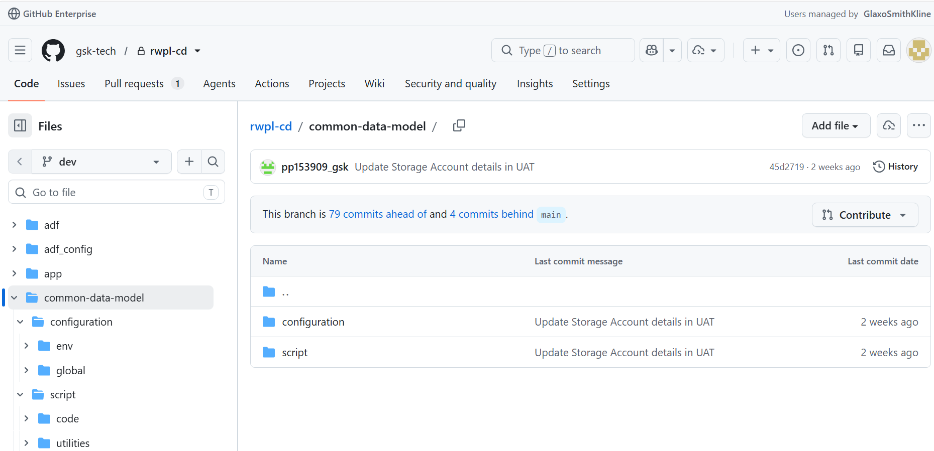

global

- Inside the config folder, all the configuration files are available. Configuration files are YAML based.

File name | Purpose
data_conversion_logic_detail_config.yaml | To store conversion transformation logics
source_data_detail.yaml | To store source data details
variables.yaml | To store all the variables that will be used in the code execution
Cohort_data_detail.yaml | To store the cohort table ids and respective names

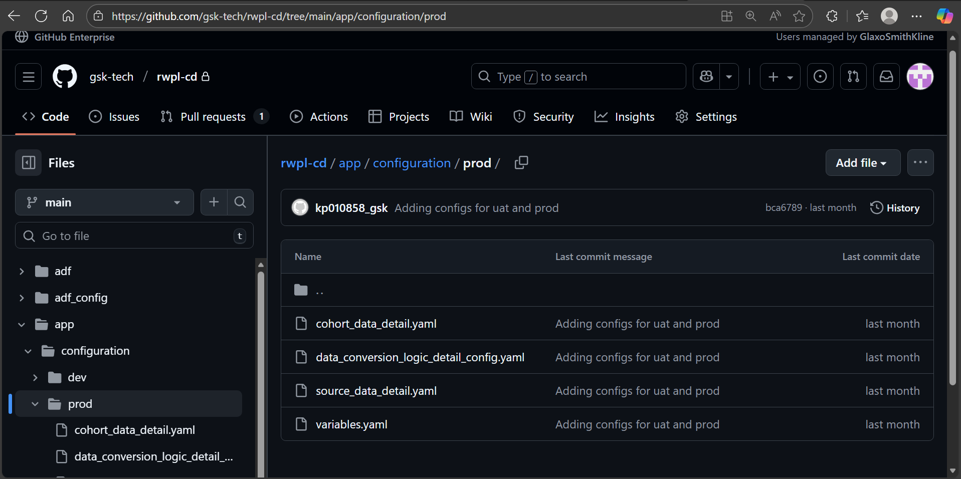

python/code/
- Inside the code folder, all the python scripts are files are available.
- Refer below grid for more details around each config file.

File name | Purpose
Data_conversion.py | Executes SQL scripts based on the logic outlined in data product yaml to generate data products.
Email_notifier.py | Provides functions to send emails, including notifications or alerts, with configurable settings.
Target_data_profiler.py | Performs basic validations on transformed data, such as null/not null checks, distinct counts, total record counts, and date range validations.
Trigger_check.py | To check whether to run the pipeline or skip it. It also checks for the refresh date parameter.

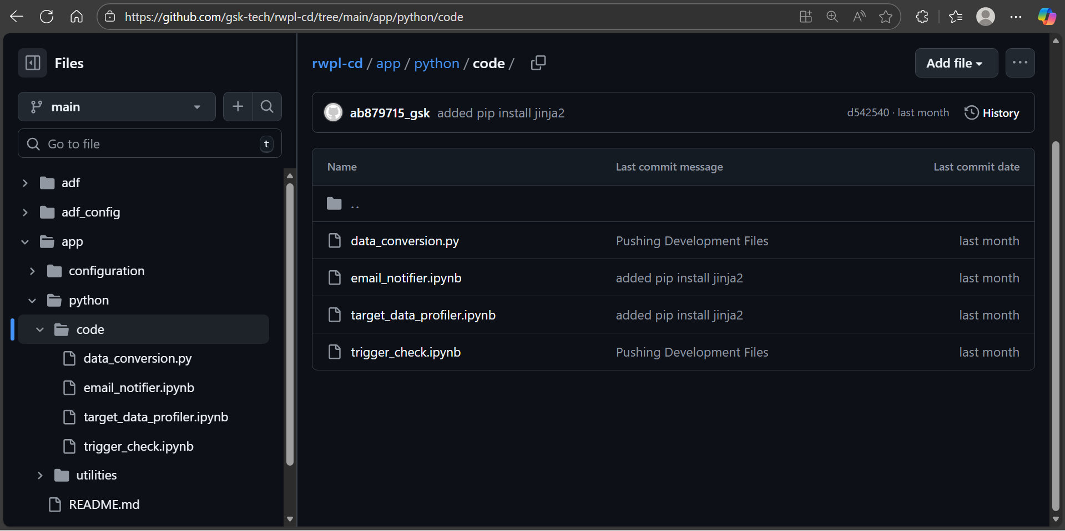

python/utilities/
- It has all the utilities used in python scripts to run the pipeline as required. Below are the utilities present inside the folder:

Utility name | Purpose
Common_constants.py | Capture values of all the constants used across all scripts
logger_utility.py | General utility for logging messages, errors, and other information for debugging or audit trails.
spark_utility.py | Offers helper functions to manage and optimize Spark sessions, data processing, and configurations.
yaml_utility.py | Facilitates reading from and writing to YAML configuration files, streamlining access to structured data.

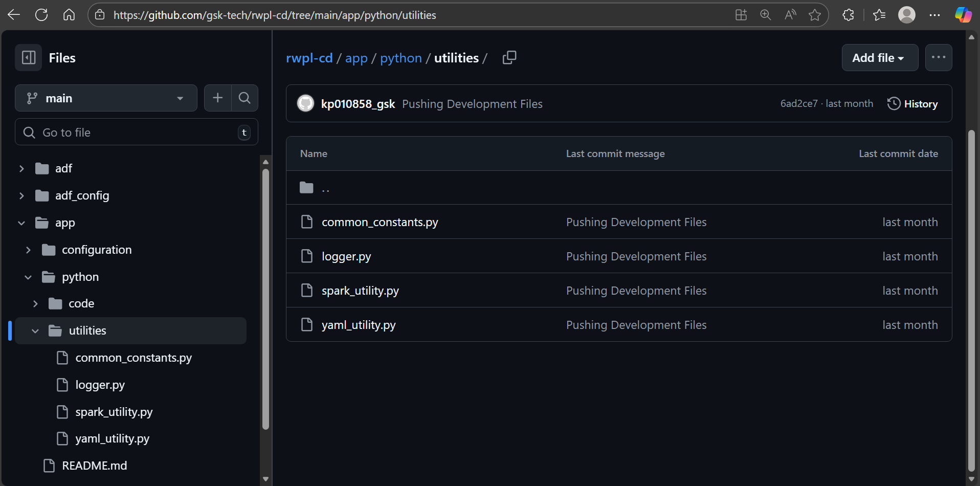

Steps to update code in Databricks & GitHub
- Go to Databricks Home page.
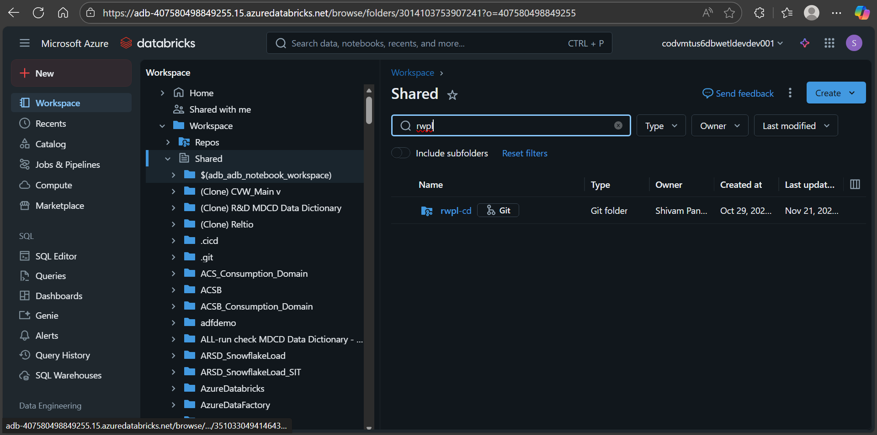
- Navigate to ‘Shared’ folder in workspace & find ‘rwpl-cd’ folder.
- Click on menu options (three vertical dots) and click on ‘git’ options.
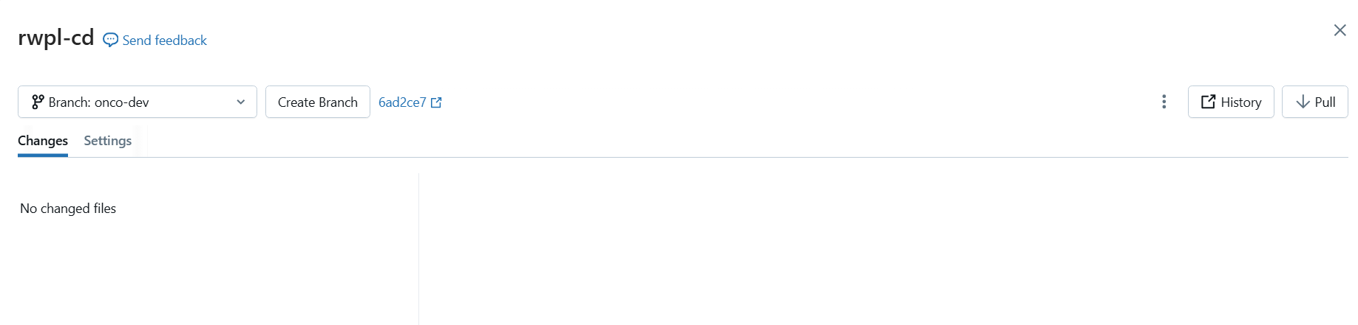
- Pull latest commits from GitHub using Pull button.
- Now update the code in Databricks Workspace in your desired file in ‘rwpl-cd’ folder.
- Once the desired changes are done, open the git window for ‘rwpl-cd’ folder.
- Select files you want to commit to GitHub. Add commit message & click on ‘Commit & Push’

Quality Management
Quality management is crucial for ensuring that our processes and outputs consistently meet established standards and stakeholder expectations. By implementing robust quality management practices, we can:
- Enhance Data Integrity: Maintaining high data quality is essential for accurate analysis and reporting. Quality management helps identify and mitigate data discrepancies, ensuring that our findings are reliable.
- Facilitate Continuous Improvement: A strong quality management framework promotes ongoing evaluation and improvement of our processes. This proactive approach enables us to adapt to changing needs and enhance efficiency over time.
- Boost Stakeholder Confidence: By demonstrating a commitment to quality, we build trust with our stakeholders. Consistent delivery of high-quality outputs reinforces our reputation and encourages collaboration.
- Support Regulatory Compliance: Effective quality management ensures that we adhere to industry regulations and standards, minimizing the risk of non-compliance and potential penalties.
- Drive Better Decision-Making: High-quality data and processes empower us to make informed decisions. By prioritizing quality management, we can enhance our strategic initiatives and ultimately improve patient outcomes.

Target DQ
The target data quality step consists of two main components. The first part involves basic profiling, which includes checks for Null/Not Null values, minimum and maximum date ranges, total counts, and distinct counts. The second part involves executing custom DQ checks, such as referential integrity and domain checks. The results of these evaluations will be stored in a CSV format on Azure Data Lake Storage (ADLS) at below path.

Environment | ADLS Path | Table Name
DEV | abfss://rwpl@codvmtus6abfstestdev001.dfs.core.windows.net/data/unified/rwpl-nonconf/flatiron_nsclc | target_profiler_output
UAT | abfss://rwpl@codvmtus6abfsuat001.dfs.core.windows.net/data/unified/rwpl-nonconf/flatiron_nsclc | target_profiler_output
PROD | abfss://rwpl@codvmtus6abfsprod001.dfs.core.windows.net/data/unified/rwpl-nonconf/flatiron_nsclc | target_profiler_output

- Each data refresh will overwrite the previous version of the QC report, and we will only maintain the report for the latest version of the data product.

Data Product Publish
Once the pipeline run is completed, it will automatically create the new version of the data product in the flatiron_nsclc schema in the DVMT consumption domain.

Note: Each data refresh will have its own separate data products, identified by the suffix <YYYY>m<MM>_v1.
For example, RWDAP_NSCLC_2025m07_v1

Changes to Dataset and Pipeline

The queries configured to enable the configuration pipeline are heavily dependent on the source data details. Thus, if any info, like a suffix, table name or column is changed in a new refresh, certain configuration files need to be updated. We have listed the suggested changes in this section.

Source Table Name Change
Follow below steps to make necessary changes in the configuration files:

- Follow steps mentioned in section 8.5 to clone the repository and make changes to code.
- Open source_data_detail.yaml file
- Update the name of relevant table.
- Once done, push the changes back to repo by following the steps mentioned in section 8.5

Source Column Name Change

Follow below steps to make necessary changes in the configuration files:

- Follow steps mentioned in section 8.5 to clone the repository and make changes to code.
- Open data_conversion_logic_detail_config.yaml file
- Search for the old column name in the entire file and replace all instances with the new column name.
- Once done, push the changes back to repo by following the steps mentioned in section 8.5

Source schema Name Change
Follow below steps to make necessary changes in the configuration files:

- Follow steps mentioned in section 8.5 to clone the repository and make changes to code.
- Open source_data_detail.yaml file
- Update the value of source_data_db key.
- Once done, push the changes back to repo by following the steps mentioned in section 8.5

Updating/Adding Target DQM check

Follow below steps to make necessary changes in the configuration files:

- Follow steps mentioned in section 8.5 to clone the repository and make changes to code.
- Open target_data_profiler.ipynb file
- Update the check as required in the target_data_profiler_entry function.
- Once done, push the changes back to repo by following the steps mentioned in section 8.5

Redeploying Updated Code in the Pipeline
Follow below steps to redeploy updated pipeline through Devops:
- Login into Azure Devops with the help of steps mentioned in section 3.5.
- Click on Pipelines in left navigation panel.

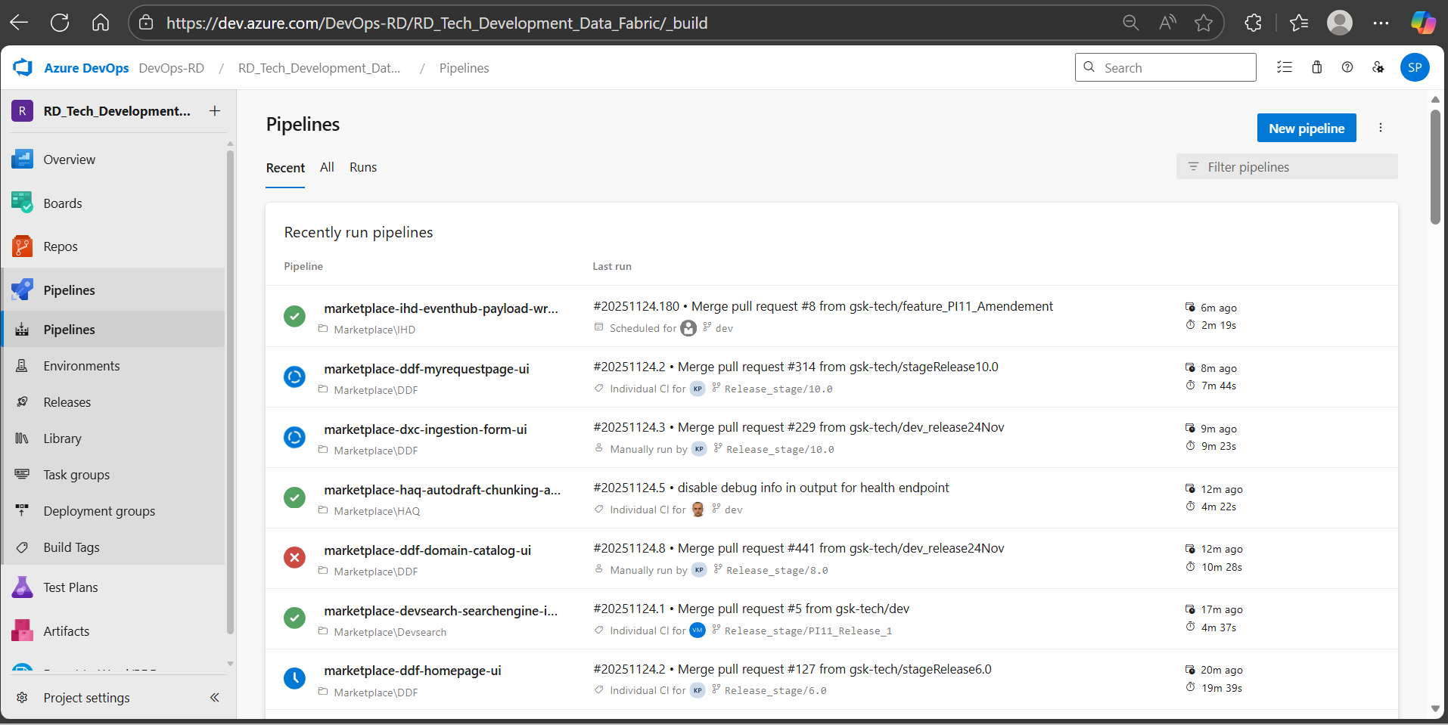

- Select the Pipeline ‘gsk-tech.rwpl-cd’.
- Click on Run Pipeline button.

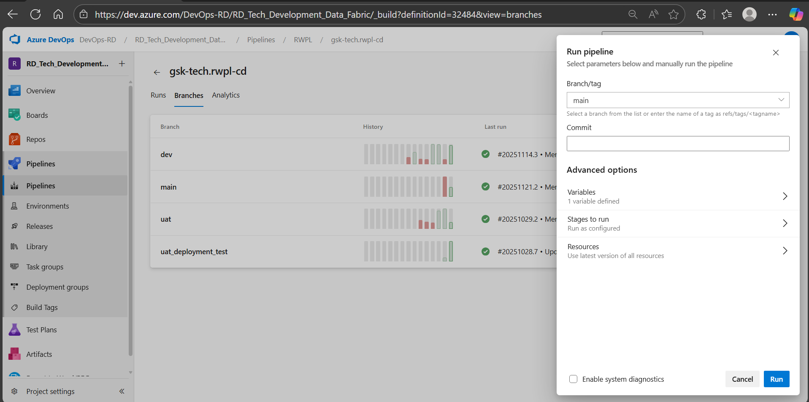
- Select ‘main’ branch in the ‘Branch/Tag’ dropdown.
- Click on Run.

Mitigation plan
Based on the latest communication received from the Eagles team, the naming convention of the source data files have been updated -
Previous source data name – nsclc_<YYYY>m<MM>_qc
Current source data name – rwd_flatiron_nsclc_<YY>m<MM>

As the source data name has been changed, we need to accommodate these changes within our code as well, below mentioned are the file names where updates will be required -

- Python/code/trigger_check.ipynb -
  - This code contains function to extract refresh date from the source data name. Additionally, we use this refresh date to create the index_end parameter dynamically.
  - Changes to the if block of code -
    - Within the year variable, we need to select first 2 values from the refresh variable and add 2000 to it, to convert it in YYYY format
    - Within the month variable, we need to select the last 2 values from the refresh variable.
  - Changes to the else block of code -
    - Within the refresh variable we need to select only the last 2 digits from the refresh_year variable, instead of selecting all 4 digits.
- Configuration/source_data_detail.yaml – We need to update the source_data_db according to the current source data name (rwd_flatiron_nsclc_{refresh}).

Appendix A

ADF pipeline steps description –

Activity Name | Short Description
Trigger Check | Runs trigger validation logic to determine run eligibility and sets run-time parameters (refresh, db name, index end date).
Set Refresh | Stores the refresh returned by Trigger Check into a pipeline variable.
Set DbName | Stores the database name returned by Trigger Check into a pipeline variable.
Set Index End Date | Stores the index end date returned by Trigger Check into a pipeline variable.
If Trigger Check Fails | Evaluates Trigger Check result; if false, routes execution to fail the pipeline.
Fail Check | Explicitly fails the pipeline when preconditions are not met.
base_table | Generates the 'base table' in the target database using the configured parameters.
min_available_date_table | Generates the 'min available date table' in the target database using the configured parameters.
Set cohort range | Computes the iteration range for the ForEach loop based on the cohorts parameter.
Set cohort | Sets the current cohort value for the ongoing ForEach iteration.
Set Counter | Sets a 1-based counter for the current ForEach iteration (used as cohort_id).
index_table | Generates the 'index table' in the target database using the configured parameters and cohort context.
clinical study drug table | Generates the 'clinical study drug table' in the target database using the configured parameters and cohort context.
fued table | Generates the 'fued table' in the target database using the configured parameters and cohort context.
biom table | Generates the 'biom table' in the target database using the configured parameters and cohort context.
pdll_table | Generates the 'pdll table' in the target database using the configured parameters and cohort context.
lab table | Generates the 'lab table' in the target database using the configured parameters and cohort context.
bp table | Generates the 'bp table' in the target database using the configured parameters and cohort context.
ecog table | Generates the 'ecog table' in the target database using the configured parameters and cohort context.
drug list table 1 | Generates the 'nsclc_ss_tbl' in the target database using the configured parameters and cohort context.
drug list table 2 | Generates the 'nsclc_csf_tbl' in the target database using the configured parameters and cohort context.
trt cat check table | Generates the 'trt cat check table' in the target database using the configured parameters and cohort context.
vitals table | Generates the 'vitals table' in the target database using the configured parameters and cohort context.
clinical study table | Generates the 'clinical study table' in the target database using the configured parameters and cohort context.
treatment_outcomes | Generates the 'treatment_outcomes' in the target database using the configured parameters and cohort context.
cohort table | Generates the 'cohort table' for each of the cohorts in the target database using the configured parameters and cohort context.
union_table | Generates the 'union table' in the target database using the configured parameters and cohort context.
RWDAP_NSCLC_v1 | Runs the final NSCLC model/version-specific transformation logic on the unioned dataset.
Target Data Profiler | Profiles the generated target data for quality/consistency checks and summary metrics.
Pipeline Successful | Marks the pipeline status as SUCCESSFUL upon completion of profiling.
If Pipeline Unsuccessful | Checks if the pipeline status was never set; if so, flags it as UNSUCCESSFUL.
Pipeline Unsuccessful | Sets the pipeline status variable to UNSUCCESSFUL.
Email Notifier | Sends a run summary email with status, trigger time, run ID, and refresh context to recipients.

